Task 2: Shell file (choose task a [print processes and calendar])

echo "hello world!"

echo "displaying processes with init"

top -n 1 | grep "init"

cal | sed '1,/19/{s/19/**/g}'

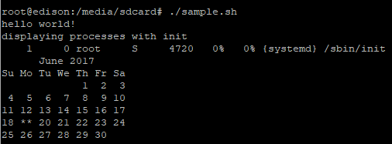

Task 3: wifi information

Picture 1 (IP of board, computer pings board, board pings bing.com (better search engine)

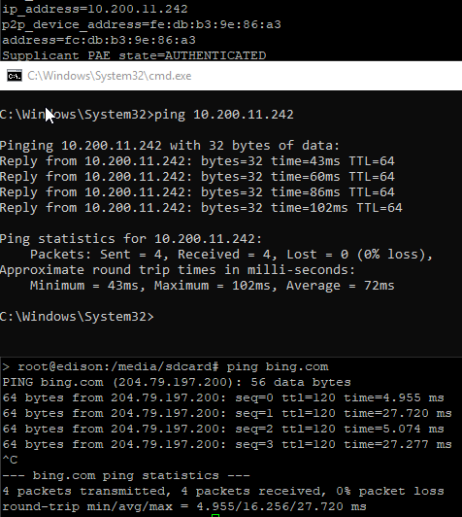

Picture 2 (IP of computer, board pings computer)

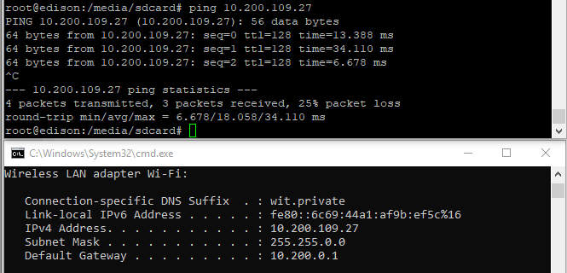

Task 4: LM35_WIDER.c

/////////////////

//Willard Wider

//7/19/18

//ELEC3800

//Lab12

//Keysignt demo

/////////////////

#include "mraa.h"

#include <stdio.h>

mraa_gpio_context MCP3208_DIN;

mraa_gpio_context MCP3208_DOUT;

mraa_gpio_context MCP3208_CLK;

mraa_gpio_context MCP3208_CS;

//vals for lab edit

char counter = 0;

int GetMCP3208 (int Channel);

int main()

{

const struct sched_param priority = {1};

sched_setscheduler (0, SCHED_FIFO, &priority);

int i;

//init the GPIO pins

MCP3208_DIN = mraa_gpio_init (11);

MCP3208_DOUT = mraa_gpio_init (24);

MCP3208_CLK = mraa_gpio_init (10);

MCP3208_CS = mraa_gpio_init (23);

mraa_gpio_use_mmaped (MCP3208_DIN, 1);

mraa_gpio_use_mmaped (MCP3208_DOUT, 1);

mraa_gpio_use_mmaped (MCP3208_CLK, 1);

mraa_gpio_use_mmaped (MCP3208_CS, 1);

//init SPI interface

mraa_gpio_dir(MCP3208_DIN, MRAA_GPIO_OUT_HIGH);

mraa_gpio_dir(MCP3208_DOUT, MRAA_GPIO_IN);

mraa_gpio_dir(MCP3208_CLK, MRAA_GPIO_OUT);

mraa_gpio_dir(MCP3208_CS, MRAA_GPIO_OUT);

//this loop is for getting each channel (if you adjusted the loop paremters)

/*

for (i = 7; i < 8; i ++)

{

printf("A%d: 0x%x\n", i, GetMCP3208 (i));

}*/

int channel = 7;

printf("Willard Wider lab 12\n");

for (i = 0; i < 50; i++)

{

int raw_vale = GetMCP3208(channel);

int decimal_value = (int)raw_vale;

decimal_value = decimal_value*500;

decimal_value = decimal_value/4096;//digital resolution

printf("Loop iteration %d, hex value of port %d is 0x%x, which is %d deg C\n",

i,channel,raw_vale,decimal_value);

}

return MRAA_SUCCESS;

}

int GetMCP3208 (int Channel)

{

int i;

int val;

mraa_gpio_write (MCP3208_DIN, 0);

//more clocking to the device

mraa_gpio_write (MCP3208_CLK, 0);

//enable the device by setting cable select to 0

mraa_gpio_write (MCP3208_CS, 0);

//0x18 = 00011000

//the 0x08 part makes it single ended config

//the 0x10 part makes it init the conversion

Channel = Channel | 0x18;

for (i = 0; i < 5; i ++)

{

if (Channel & 0x10)

{

mraa_gpio_write (MCP3208_DIN, 1);

}

else

{

mraa_gpio_write (MCP3208_DIN, 0);

}

Channel <<= 1;

//clocking

mraa_gpio_write (MCP3208_CLK, 0);

mraa_gpio_write (MCP3208_CLK, 1);

}

//send the clock thorugh for the conversion...

mraa_gpio_write (MCP3208_CLK, 0);

mraa_gpio_write (MCP3208_CLK, 1);

mraa_gpio_write (MCP3208_CLK, 0);

mraa_gpio_write (MCP3208_CLK, 1);

val = 0;

for (i = 0; i < 12; i ++)

{

//more clocking...

mraa_gpio_write (MCP3208_CLK, 0);

mraa_gpio_write (MCP3208_CLK, 1);

//...and finally get the value

val = (val << 1) | ((int) mraa_gpio_read (MCP3208_DOUT));

}

mraa_gpio_write (MCP3208_CS, 1);

mraa_gpio_write (MCP3208_DIN, 0);

mraa_gpio_write (MCP3208_CLK, 0);

return val;

}

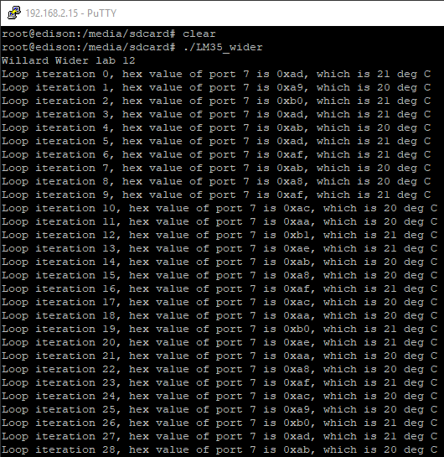

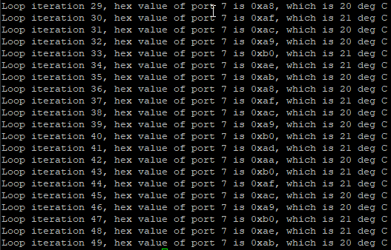

TempDisplay_WIDER.c

#include "mraa.h"

#include <stdio.h>

#define addr 0x7C

mraa_gpio_context reset;

mraa_gpio_context sda;

mraa_gpio_context scl;

mraa_gpio_context MCP3208_DIN;

mraa_gpio_context MCP3208_DOUT;

mraa_gpio_context MCP3208_CLK;

mraa_gpio_context MCP3208_CS;

void delay_time (unsigned int time_end)

{

unsigned int index;

for (index = 0; index < time_end; index++);

}

void i2c_start (void)

{

mraa_gpio_write(sda, 1);

mraa_gpio_write(scl, 1);

delay_time (100);

mraa_gpio_write(sda, 0);

mraa_gpio_write(scl, 0);

}

void i2c_stop (void)

{

mraa_gpio_write(scl, 0);

mraa_gpio_write(sda, 0);

mraa_gpio_write(scl, 1);

delay_time (100);

mraa_gpio_write(sda, 1);

}

void i2c_write (unsigned char output_data)

{

unsigned char index;

for(index = 0; index < 8; index++) // Send 8 bits to the I2C Bus

{

if (output_data & 0x80)

{

mraa_gpio_write(sda, 1);

}

else

{

mraa_gpio_write(sda, 0);

}

output_data <<= 1; // Shift the byte by one bit

mraa_gpio_write(scl, 1);

delay_time (100);

mraa_gpio_write(scl, 0);

}

mraa_gpio_write(scl, 1);

delay_time (100);

mraa_gpio_write(scl, 0);

}

void LCD_Print (char* str)

{

i2c_start ();

i2c_write (addr);

i2c_write (0x00);

i2c_write (0x01);

i2c_stop();

i2c_start ();

i2c_write (addr);

i2c_write (0x40);

for (; *str != '\0'; str ++)

{

i2c_write (*str);

}

i2c_stop();

}

void init_LCD (void)

{

i2c_start ();

i2c_write (addr);

i2c_write (0x00);

i2c_write (0x38);

i2c_stop();

i2c_start ();

i2c_write (addr);

i2c_write (0x00);

i2c_write (0x39);

i2c_stop();

i2c_start ();

i2c_write (addr);

i2c_write (0x00);

i2c_write (0x14);

i2c_stop();

i2c_start ();

i2c_write (addr);

i2c_write (0x00);

i2c_write (0x79);

i2c_stop();

i2c_start ();

i2c_write (addr);

i2c_write (0x00);

i2c_write (0x50);

i2c_stop();

i2c_start ();

i2c_write (addr);

i2c_write (0x00);

i2c_write (0x6C);

i2c_stop();

delay_time (300);

i2c_start ();

i2c_write (addr);

i2c_write (0x00);

i2c_write (0x0C);

i2c_stop();

i2c_start ();

i2c_write (addr);

i2c_write (0x00);

i2c_write (0x01);

i2c_stop();

}

int GetMCP3208 (int Channel);

int main()

{

const struct sched_param priority = {1};

sched_setscheduler (0, SCHED_FIFO, &priority);

int i;

char buf [25];

reset = mraa_gpio_init(36);

sda = mraa_gpio_init(7);

scl = mraa_gpio_init(19);

MCP3208_DIN = mraa_gpio_init (11);

MCP3208_DOUT = mraa_gpio_init (24);

MCP3208_CLK = mraa_gpio_init (10);

MCP3208_CS = mraa_gpio_init (23);

mraa_gpio_dir(reset, MRAA_GPIO_OUT);

mraa_gpio_dir(sda, MRAA_GPIO_OUT);

mraa_gpio_dir(scl, MRAA_GPIO_OUT);

mraa_gpio_use_mmaped (MCP3208_DIN, 1);

mraa_gpio_use_mmaped (MCP3208_DOUT, 1);

mraa_gpio_use_mmaped (MCP3208_CLK, 1);

mraa_gpio_use_mmaped (MCP3208_CS, 1);

mraa_gpio_dir(MCP3208_DIN, MRAA_GPIO_OUT_HIGH);

mraa_gpio_dir(MCP3208_DOUT, MRAA_GPIO_IN);

mraa_gpio_dir(MCP3208_CLK, MRAA_GPIO_OUT);

mraa_gpio_dir(MCP3208_CS, MRAA_GPIO_OUT);

mraa_gpio_write(reset, 0);

delay_time (500);

mraa_gpio_write(reset, 1);

delay_time (500);

init_LCD ();

while (1)

{

sprintf (buf, "WW: Temp: %3.1f%cC", (float) GetMCP3208 (7) * 500 / 4096, 0xDF);

LCD_Print (buf);

sleep (1);

}

return MRAA_SUCCESS;

}

int GetMCP3208 (int Channel)

{

int i;

int val;

mraa_gpio_write (MCP3208_DIN, 0);

mraa_gpio_write (MCP3208_CLK, 0);

mraa_gpio_write (MCP3208_CS, 0);

Channel = Channel | 0x18;

for (i = 0; i < 5; i ++)

{

if (Channel & 0x10)

{

mraa_gpio_write (MCP3208_DIN, 1);

}

else

{

mraa_gpio_write (MCP3208_DIN, 0);

}

Channel <<= 1;

mraa_gpio_write (MCP3208_CLK, 0);

mraa_gpio_write (MCP3208_CLK, 1);

}

mraa_gpio_write (MCP3208_CLK, 0);

mraa_gpio_write (MCP3208_CLK, 1);

mraa_gpio_write (MCP3208_CLK, 0);

mraa_gpio_write (MCP3208_CLK, 1);

val = 0;

for (i = 0; i < 12; i ++)

{

mraa_gpio_write (MCP3208_CLK, 0);

mraa_gpio_write (MCP3208_CLK, 1);

val = (val << 1) | ((int) mraa_gpio_read (MCP3208_DOUT));

}

mraa_gpio_write (MCP3208_CS, 1);

mraa_gpio_write (MCP3208_DIN, 0);

mraa_gpio_write (MCP3208_CLK, 0);

return val;

}

